Exam 3 Basic lecture outline
Check page breaks before printing

VII. Populations

A. Population genetics:
1. Calculating allele frequencies:
a. if a population is 360 BB, 480 Bb, and 160 bb, what are the
frequencies of B and b?
b. p = freq. of dominant (B) =
q = freq. of recessive (b) =

c.
2. What will be the genotype frequencies in the next generation?
freq. BB =
freq. bb =
freq. Bb =
3. What are allele frequencies if BB = 60% and bb = 40%?
(can assume a population size of 1000)
freq. B = p =
freq. b = q =
4. What will the genotype frequencies be in the next generation?

5. Hardy - Weinberg conditions:
frequencies cannot change if
a.
b.
c.
1)
2)
a) a small population is
b)
c)
d.
e.
6. how common are these conditions in nature ?
7.
a. if 360 BB, 480 Bb, 160 bb (p = 0.6, q = 0.4)
b. if all bb's die,

c. if all bb's keep dying, what will happen to p and q?
p: 0.60 0.71 0.77 0.82 0.85 0.863 ... 0.985
q: 0.40 0.29 0.23 0.18 0.15 0.137 ... 0.015
d. will ‘b’ ever disappear?
1) theoretically
2) practically

8.
a.
b.
c.
the fact that some types don't survive
because they are disadvantaged by some of their genes.

B.
1. means
2. consequences
a. genetically:
b. ecologically:
c. fitness:

3. types of selection
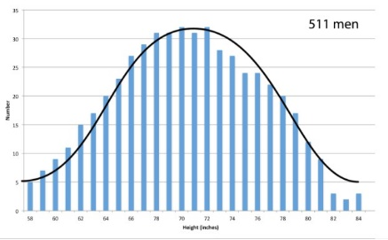
a. most traits are influenced by many genes
1)
2)
3) example: height
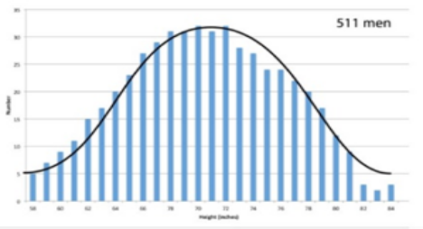

b.
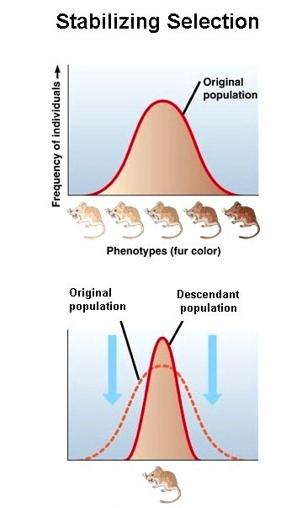
1)
2) average tends to ....

c.
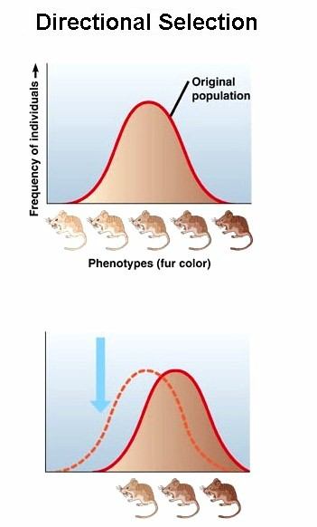
1)
2)

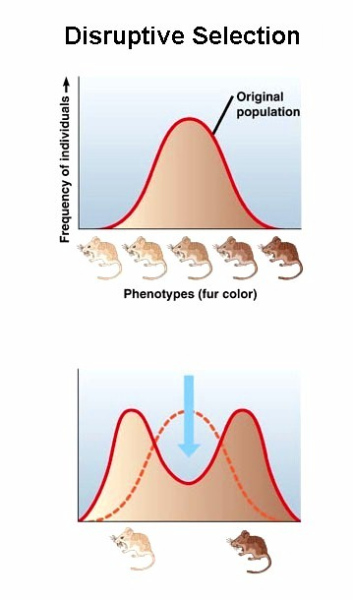
d.
1)
2)

4. fitness
a.
b.
c.

C.
1. scales
a.
1) e.g. peppered moth (Ricklefs p. 130)
a) sleeps on trunks in day, eaten by birds
b) pre 1850s
(1) mostly spotted moths (A_) p = 0.92 q = 0.08
(2) well camoflaged for lichens
c) post 1880
(1) pollution kills lichens, trunks are black
(2) mostly black moths (aa) p = 0.01 q = 0.99
(3) being dark was an advantage
(4) soon, 98% of moths in a forest were black
d) moral
(1)
(2)
2)
a)
b) examples
(1) chickens:
(2) cows:
(3) grain:
c)
b. macroevolution =
1) result of long-term (100's of generations) microevolution
2)
3)

4)
2. populations must change if
a.
b.
c.
3. populations do change if
a.
b.
4. facts
a.
b.
c. Darwin's theory
1)
2)
3)
4)
5. patterns of speciation
a.
1)
2)

3)
a)
b)
c)
d) example: fruit flies in Hawaii
b.
1)

2)
3)
c. same thing happens in languages
6. rates of speciation
a.
1)
2)
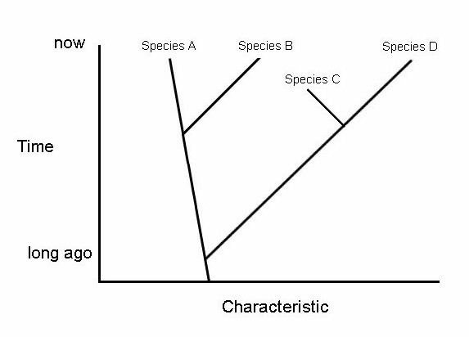

b. Gould & Eldridge
1)
2)
3)
4)
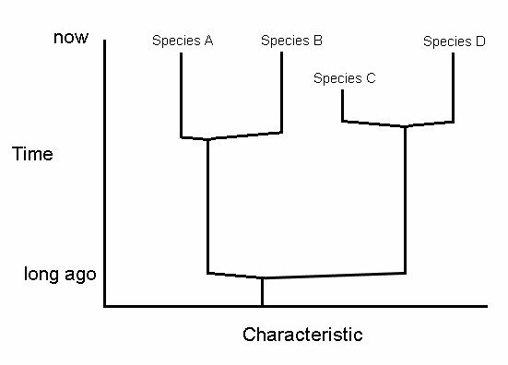

7. controversy: evolution and creation
a. science
1) based on testable hypotheses
2) hypotheses are critiqued and maybe disproven
a) “hypothetical” and “theoretical” in common use

b) in science, these reflect levels of certainty:
(1) observation: has been
(2) hypothesis:
(3) theory:

(4) law:
3) science reveals facts about the observable universe
4) “Do you believe” in evolution?

b. faith
1) is based on concepts of
2) none of which are
3) belief vs. knowledge
c. arguments
1) “irreducible complexity”
a) structures that are complex, but

b) but every candidate so far has been shown to be

2) “not enough time”
a) assumes evolution is

b) but evolution doesn’t start fresh every time

c) also 4 billion years is an incomprehensibly LONG time

3) “gaps in the fossil record”
a) are illusions:
b) where are the intermediate forms (“missing links”) ?
(1)
(2) or
(3) or
4) “assume what you’re trying to prove”
example: Institute for Creation Research applies the
scientific method to disprove evolution.
5) there have been many attacks on faith, but these are
beyond the scope of this course
d. what to teach in school ?
1) teaching faith in school implies the government supports
a particular religion
2) teaching faith as science undermines critical thinking:
“God made it that way, and we can never understand His
purpose.”
a)

b)
3) science cannot prove or disprove a creator, but it can
reveal facts about the universe
4) Pope John Paul II: “...new knowledge leads us to
recognize that the theory of evolution is more than a
hypothesis.” (Time, October 1996)
a) science explains life
b) faith explains the soul
e. conclusion
1) it’s not my job to tell you what to believe, but it is my job to
help you understand the world around us
2) we should teach children to use their brains, and to make
decisions based on facts

D. Ecology
1. study of
a.
b.
c.
d.
1) everything that a species needs or interacts with
2)
3) competitive exclusion:

2. niche components
a. physical concerns
1)
2)
3)
4) etc
b. biological concerns
1)
a)
b)

c)
2)
a)

b) one predator / one prey system:

c) multiple prey
(1)
(2)
(3) more stable
d)
3. energetics
a. trophic levels:
b. food chains:
1) plants --> herbivores --> 1^{O} carnivores --> 2^{O} carnivores
2) efficiency:
c. food webs: consider species & age
1) first trophic level:
2) second trophic level:
3) third trophic level:
4) fourth trophic level:
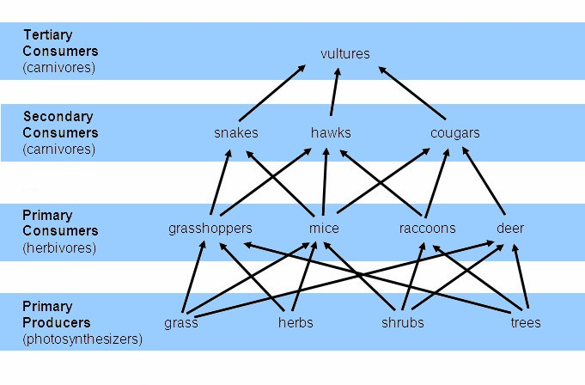

5) rarely that simple
4. community stability
a. stability is
b. few species:
c. many species:

5. survivorship patterns
a. Type I:
b. Type II:
c. Type III:
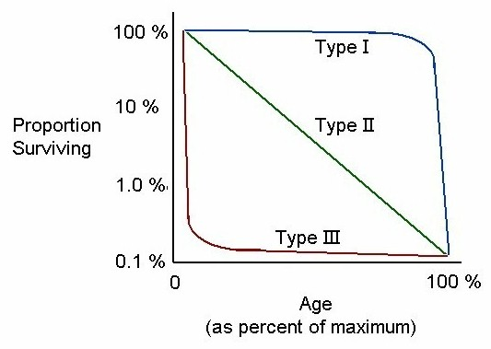
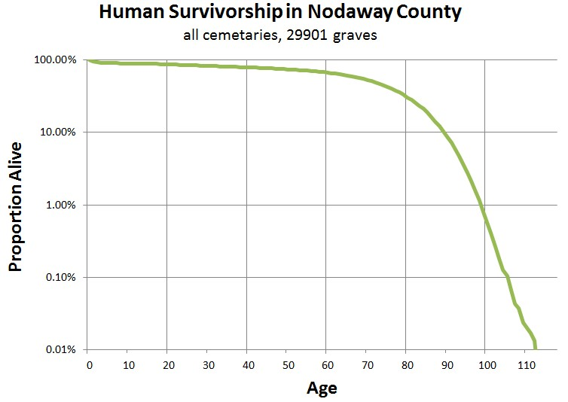

6. life history strategies
a. patterns of energy use, competition, and reproduction
 | r-adapted species | K-adapted species
Juvenile survival
Number of reproductive events
Proportion of energy used in reproduction
Parental care
Good dispersers?
Good competitors?
Self-renewing communities?

b. r-adapted species
1) are
2) examples:
c. K-adapted species
1) form
2) examples:
d.

VIII. Animal Biology

A. Reproduction
1. gametogenesis
a. spermatogenesis
1) mitosis can
2) germ cells
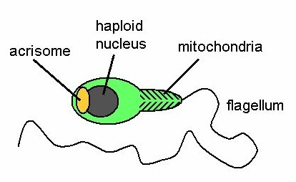
3) final product
a) one set
b)
c)
d)
b. oogenesis
1) germ cells made
2) meiosis
3) final product
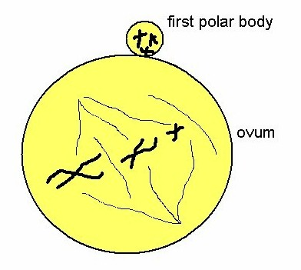
a) about
b) at
c)
2. fertilization
a.
1)
2)
3)
4)
b. sperm meets egg
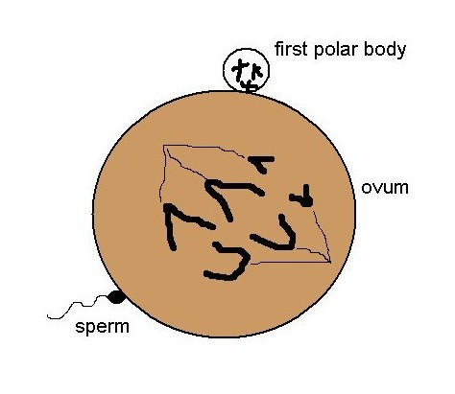
1) egg response
a)

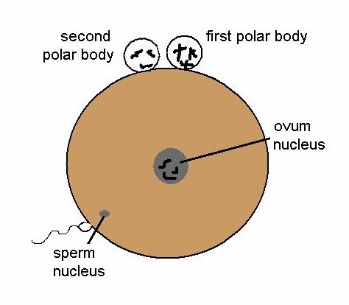
b)

2) enzymes of

c.
d.
e. nuclei fuse:

B. Development
1.
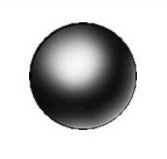
a.
b. in humans,

2. morula (cleavage = initial mitoses)
a.
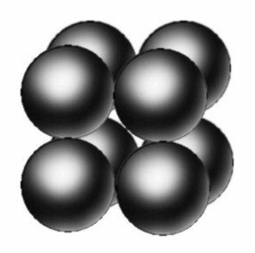
b.
c.
d.
e. identical twins
1)
2)
3)
4)
3. blastula (blastocyst) (Day 4 to Day 14)
a.
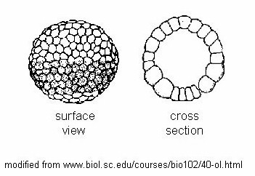
b.
c.
d.
e.
f.
4. gastrula (embryo; larva)
a.
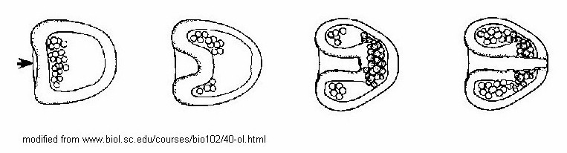

b.
1) ectoderm:
2) mesoderm:
3) endoderm:
c. cell migrations, e.g. neurulation
d. Day 27:
e.
5. controversy: genetic engineering
a. cloning
1) use DNA from an ideal individual to make many zygotes
2) new zygotes have same DNA and same characteristics
3) applications
a) food production: rapidly increase

b) conservation: allows re-generation of

c) re-generate a beloved pet
4) cloning humans: ethical?
Technology provides the means, but not the wisdom
b. stem cells
1) cell differentiation
a) early in development
(1) cells are
(2) the zygote cell will produce
(3) liver, brain, bone, skin, eyes, T-cells, etc
b) as the embryo develops beyond
(1) potential cell types
(2) cell development is
2) stem cells are early cells that still have

3) stem cells can be guided to develop in particular ways
4) possible benefits
a) growing
b)
curing many diseases (examples: Parkinson’s,
Alzheimer’s, diabetes, sickle-cell anemia)
5) concerns
a) new cells
b) embryonic stem cells are harvested from
blastocysts:
(1)
(2) such blastocysts often occur as a
by-product of in vitro fertilization
(3) a new alternative: harvest skin cells,
activate the genes that allow all pathways,
grow into a mass of stem cells
c) playing “God”
d) designer babies

C. Digestion in vertebrates
1. mouth
a.
b.
c.
2. esophagus
3. stomach
a.
b.
c.
4. small intestine
a.
1)
a)
b)
2)
a)
b)
b. absorption
1)
2)
3)
4)
5)
5. large intestine:
6. some variations
a. ruminants (cattle, deer)
1)
2)
b. horses:
c. rodents (rabbits, rats)
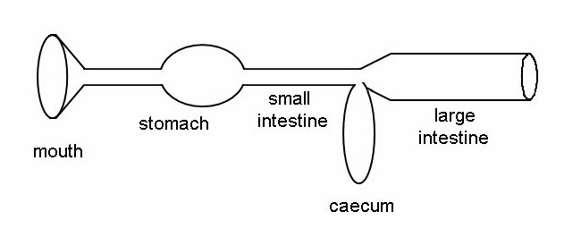

1) caecum
2)
3)
4)

D. Excretion
1. lungs:
2. liver
a.
b.
c.
3. kidney: major excretor
a. overall structure
b. nephron structure
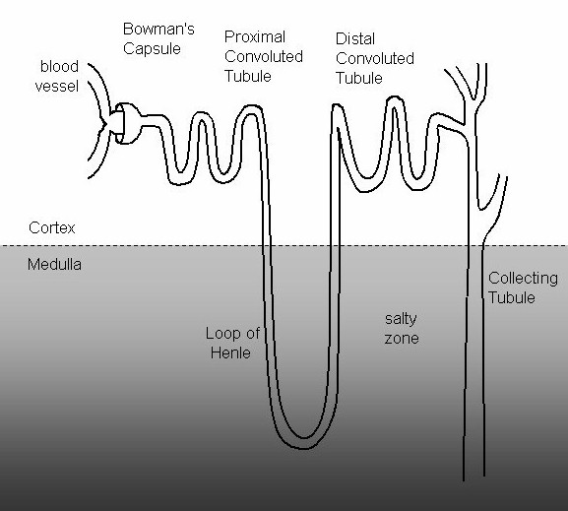

c. nephron functioning
1)
a)
b) everything enters nephron except
(1)
(2)
(3)
2) proximal convoluted tubule
a)
b) recovers
c)
3) loop of Henle
a)
b) longer loop =
4) distal convoluted tubule
a)
b)
5) collecting tubule
a) controls
b)

c)
d)
e) permeability influenced by
(1) diuretics
(a)
(b)
(c)
(2) antidiuretics
(a)
(b)
d. basic idea:

E. Nerves: bundles of neurons
1. neurons (nerve cell)
a. structure
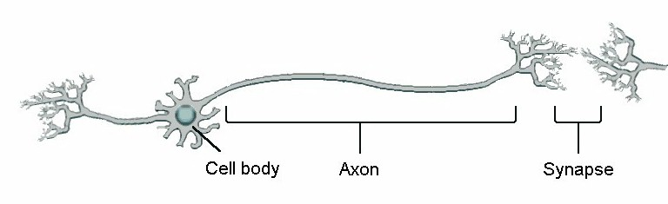

b. neuron conduction
1) normal state
a) pumping out
b) outside is
c) inside are large
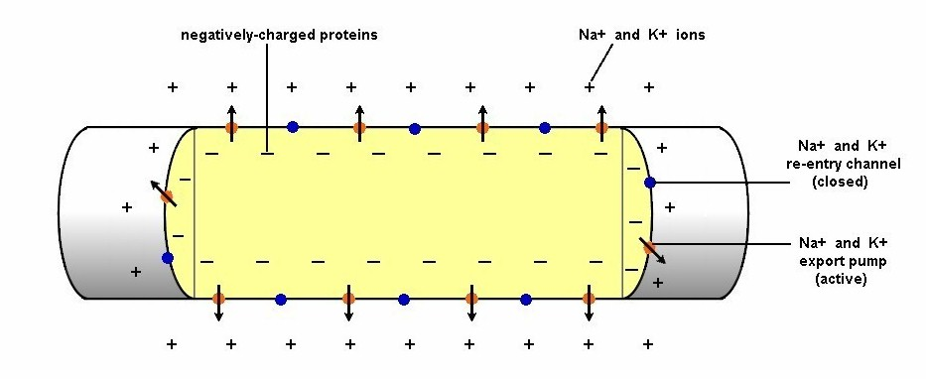

2) nerve impulse
a) temporary
b) inside becomes
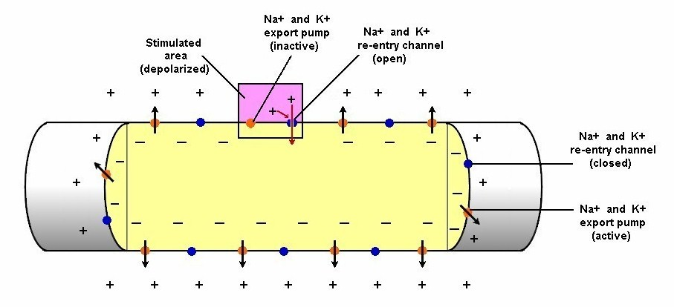

c) causes
d)
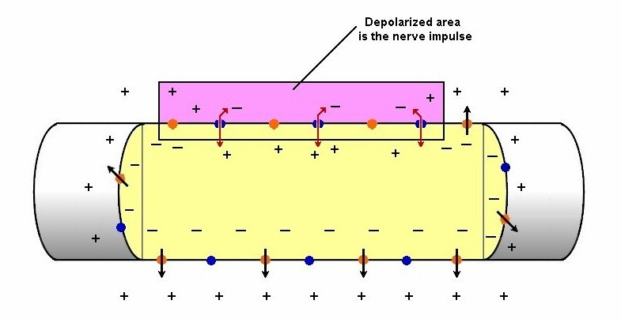

2. nerve conduction (multiple neurons)
a) one way conduction because
1) neurotransmitters
2) nerve impulse causes

3) neurotransmitters
4) receptors
5) these
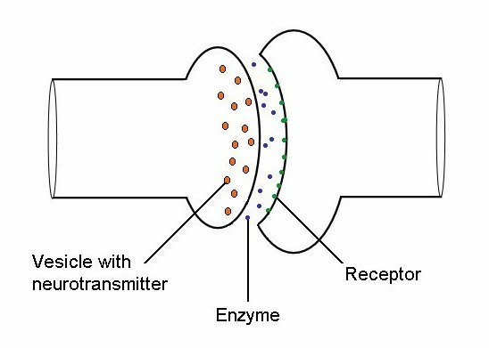

6) finally, enzymes
b. nerve gasses
1)
2)
3)
c. myelin
1)
2)
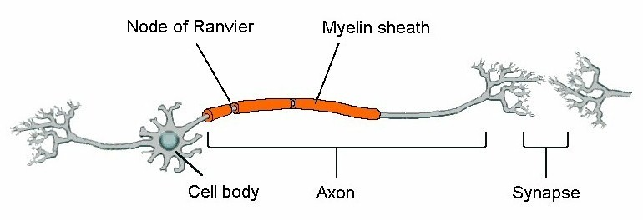

3)
4)
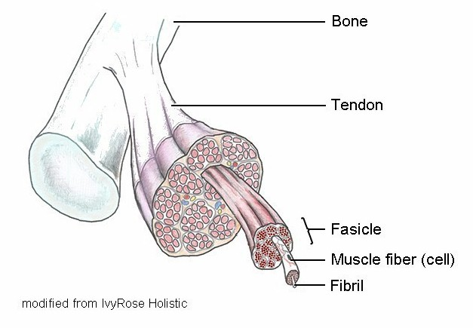

F. Muscles
1. structure: cells arelong cylinders
2. steps
a. arrival of nerve impulse
b. Ca and ATP attach
c. myosin heads
d. myosin heads
e. heads
f. Ca and ADP
g. pulls 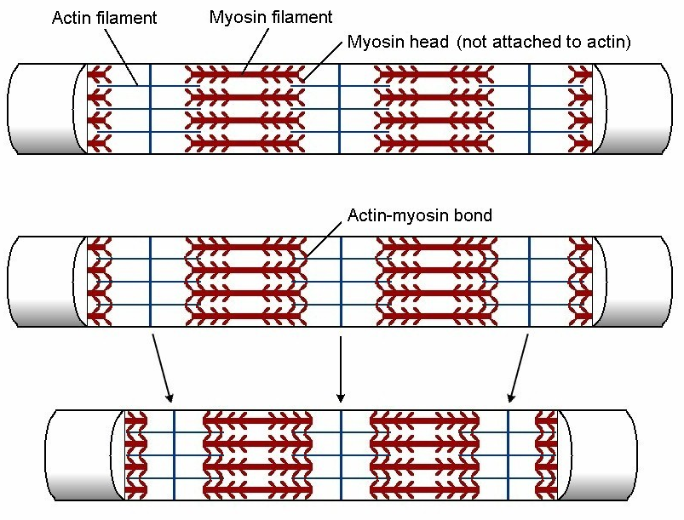

Reminder: video on Canvas and from 1:42 to 2:48 on the video on YouTube:
www.youtube.com/watch?v=sIH8uOg8ddw

3. rigor mortis
a.
b.
4.

G. Respiration (gas exchange)
1. anatomy
a. lungs
1)
2)
3)
4)
a)
b)
b. skin
1) if
2) then
3)
c. gills:
d. trachea
1) insects
2)
3)
2. respiratory pigments
a.
b. hemoglobin (Hb)
1)
2) red = oxygenated,
3)

c. myoglobin
1)
2)
d. other pigments: hemerythrin, hemocyanin

H. Circulation
1. transports oxygen, carbon dioxide, glucose, hormones,
small fats, wastes, blood cells
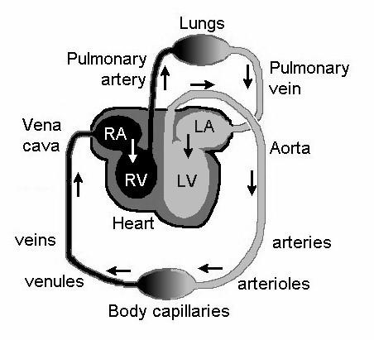
2. human heart
a.
b. flow pattern
c.

d. blood pressure
1) systole is
2) pushes
3) diastolic is
4) 120/80 = systolic/diastolic
e. pulse rate
1) internal nerves
2) external nerves
3) chamber filling rate

f. heart attacks
1) blockage
2) muscle is deprived of
3) treatments
a) bypass:
b) angioplasty
(1)
(2)
3. vessels
a. arteries and arterioles
1) arterioles:
2) carry blood
3) usually
4)
5)
6)
b. capillaries
1) deliver
2)
3)
c. venules and veins
1) venules =
2) carry
3) usually
4)
5)
6) pressure in venules only about 46 mmHg
a) return to heart
b) valves
7) vena cavae

I. Hormones
1. are messengers
a.
b.
c.
2. affect
3. coordinate body
a.
b.
c. examples:
4. types
a. steroids (fat-like)
1)
2) examples
a) estrogen
b) testosterone
c) aldosterone
b. polypeptides and amines (protein-like)
1)
2)
3) examples
a) insulin
b) antidiuretic hormone
c) adrenalin

J. Immunity: defense against "non-self" (antigen = invader)
1. components
a. antibodies
1) made by B-cells
2)
3) antibodies are
b. cytotoxic T-cells (killer T’s):

c. helper T-cells
1)
2) attacked by HIV
2. the primary immune response (first invasion)
a. virgin B-cells:
1) eventually
2) become
a) mitosis to
b) these make the
b. killer T's digest the
c. hundreds of B-cells
3. the secondary response: re-exposure
a. memory B-cells are
b. because there
c. response time is
4. vaccines
a. simulate invasion using
b. therefore force the body to
c. controversy: should vaccines be avoided ?
1) reasons vaccines are avoided
a)
b) skepticism:

c) vaccines are unsafe:
(e.g. flu vaccines and autism)
d) vaccines interfere
2) facts
a) the disease is worse than the vaccine
b) reduction in vaccination rate allows

c) vaccinations protect
spread of the disease
d)

5. HIV
a. infection rates
1) global
a)
b) 900,000 new cases per year
c)
2) U.S.: 1,150,000 alive
a) 50,000 new cases per year
b) rate declined in early
c) 636,000 have died (as of 2014)
3) U.S. distribution
a) 42% homosexual
b) 33%
c) 25%
b. the disease
1) attacks helper T-cells
2)
a) every week or so
b) by the time antibodies are

c) seems like
3) body is able to fight them off

4) death usually by "minor" infection (pneumonia)
c. treatments
1) replication blockers (ex: AZT, protease inhibitors)
a)
b) reduces rate of viral reproduction
2) decoys
a)
b) reduces rate of invasion
3) vaccine
a)
b)
c)
d) none very successful yet
4) multiple drug therapies ("cocktails")
a)
b)
c) cost is $12,000 to $20,000 per year
d) must stick to drug schedule very closely
5) best bet is
6) 'non-susceptibility'
a)
b)
c)
d) if HIV becomes common, will this defect become
common?
e) update 2020:

K. Cancer
1. is
2. tumor types
a.
b.
c.
3. causes
a.
b.
c.
d.
e.
4. treatment
a.
b.
c.
d.
e.
f.

L. Human health
1. diet
a. food pyramids
1) traditional USDA
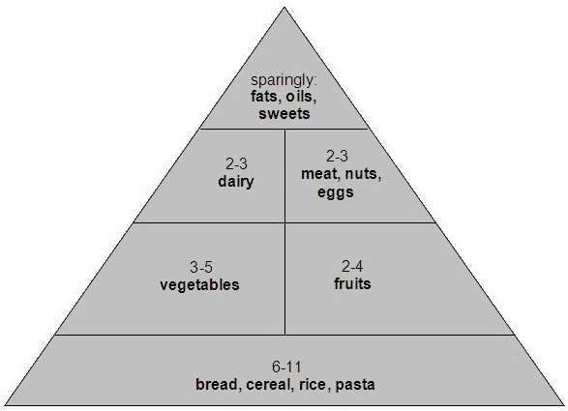
(1991)

2) Harvard
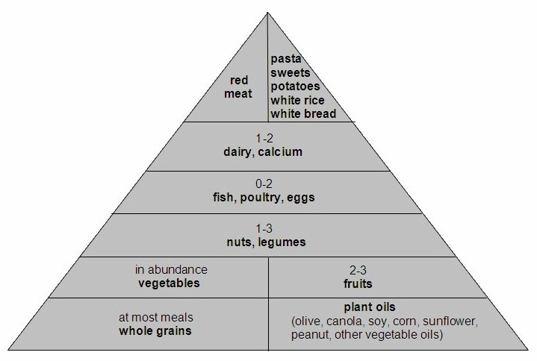
(2004)

3) USDA revised (2005)
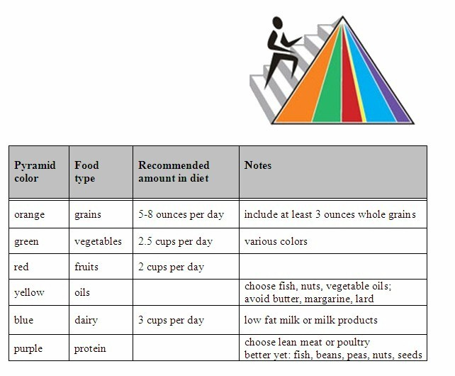

b. low fat vs. low carb
1)
2)
c. fats & oils
1) rank (worse to better)
a)
b)
c)
2) cholesterol types
a)
(1)
(2)
b)
(1)
(2)
3) influences
a)
b)
4) limits
a)
b)

5) recommendation
a)
b)
c)
d. vitamins & minerals
1)
2)
3) cooking
4) most Americans need
5) folic acid
a) reduces risk of
b)
6) fiber: decreases risk of
a)
b)
e. controversy: food additives
 | Pros | Cons
Animal hormones | faster animal growth | effects are likely on  humans, wildlife
Animal antibiotics | better animal health | microbial resistance
Preservatives | reduced spoilage | effects unknown: maybe  allergies, sensitivities

2. exercise
a. American Heart Assn recommends
1)
2)
3) target pulse range
a) 1/2 to 3/4 of (220 - age)
b)
b. American College of Sports Medicine (2011)
Type | Time & Components
Aerobic | moderate: 5 days/week, 30-60 min each, or  vigorous: 3 days/week, 20-60 min each
Resistance | 2-3 days/week, 2-4 sets each, 8-12 reps/set,  2-3 min rest between
Flexibility | 2-3 days/week, hold stretches for 10- 30 sec, repeat each 2-4 times
Functional | 2-3 days/week, 20-30 min each  (e.g. yoga, tai chi, pilates)

c. World Health Organization (2013) recommends
1)
2)
d. e. all will decrease stress
e.
3. habits
a.
1)
2) effective delivery to lungs & blood of
a)
b)
3) greatly increased risk of
a)
b)
c)
d)
e)
f)
(1)
(2)
g)
b. medicines
1)
2)
3)
4)
5) controversy: use of antibiotics
a) have greatly reduced illnesses since 1950
b) natural selection has

c) now some are almost
(1) e.g. MRSA: methicillin-resistant
Staphylococccus aureus
(2) kills
d) yet now we have antimicrobial soap, and antibiotics
prescribed without much thought
e)
c. stress
1)
2)
3)
a)
b)
4)
d. doctors
1)
a)
(1)
(2)
(3)
b)
c)
2)
3)
a)
b)
c)
e.
4. weight
a. fad diets
b. each person has
c. avoid
d. to lose 10% of body weight,
e. average American adult consumes
1) only needs about
2)
f. limit sugar to
g. body mass index (BMI):
1) 703 x weight (lbs) / (height x height) (inches)
2) indicates health risk
a) 18.5 – 24.9 is normal
b) 25 – 29.9 is overweight
c) > 30 is obese
5. long life
a.
1)
2)
3) diet
a)
b)
c)
d)

4) aspirin
a)
b)
5) alcohol
a)

b)
c)
d)
e)
b.
1)
2)
3)
4)
a) choose mainly
b)
c) some specific foods inhibit some cancers:

d)
c. watch your weight
1) BMI over 30 means

2)
d. avoid HIV
e. sex
1)
2)
3)
f. salt
1)
2)
g. water
1)
a)
b)
2)
3)
h.
1) up to age 30:
2) 31-44:
3) over 45:
4) main benefit:
i. get enough sleep
1)
2)
3)
j. use common sense
6. top killers
Rank | College-age  (15-24 years old) | Overall U.S.  population
1
2
3
4
5
6
7
8
9
10

7. electronic resources
a. www.myfitnesspal.com/exercise/lookup: calories
b. www.caloriecontrol.org: calories
c. www.consumerreportshealth.org/heartrisk: heart risk
d. http://www.weather.com/activities/health/fitness/: hydration
e. ”Lifex” spreadsheet on eCompanion: longevity

end of Exam 3 material

